**PROJECT REPORT TEMPLATE**

**1.INTRODUCTION**

**1.1 Overview**

Briefly introduce the topic of the impact of Apple iPhones in India. Highlight the significance of analyzing data to understand this impact . Contribution to the Indian economy in terms of jobs and revenue . Comparison charts showing Apple's economic impact in India. Predictions for iPhone's future growth and evolution in the Indian market . Visualizations showcasing future market projections and potential areas of expansion.

**1.2 Purpose**

**Analyze Market Penetration:** Understand the extent to which iPhones have penetrated the Indian market and their market share compared to other smartphone brands.

**Economic Impact:** Assess the economic impact of iPhone sales in India, including job creation, revenue generation, and contributions to the local economy.

**Consumer Behavior:** Study consumer behavior regarding iPhone purchases, including factors influencing buying decisions and brand loyalty.

**Digital Divide:** Investigate how iPhone usage affects the digital divide in India, considering factors like urban-rural usage disparities and access to advanced technology.

**Social Impact:** Explore the social implications of iPhone usage, such as its influence on social interactions, communication patterns, and lifestyle choices.

**Education and Innovation:** Examine how iPhones are used in education and innovation sectors, including apps developed for educational purposes and their impact on learning outcomes**.**

**Environmental Impact**: Investigate the environmental footprint of iPhones in India, including e-waste management, recycling efforts, and sustainable practices.

**Policy Implications:** Analyze the regulatory and policy aspects related to iPhone sales and usage in India, including import/export policies, taxation, and government initiatives.

**2.PROBLEM DEFINITION AND DESIGN THINKING**

**2.1 Empathy Map**

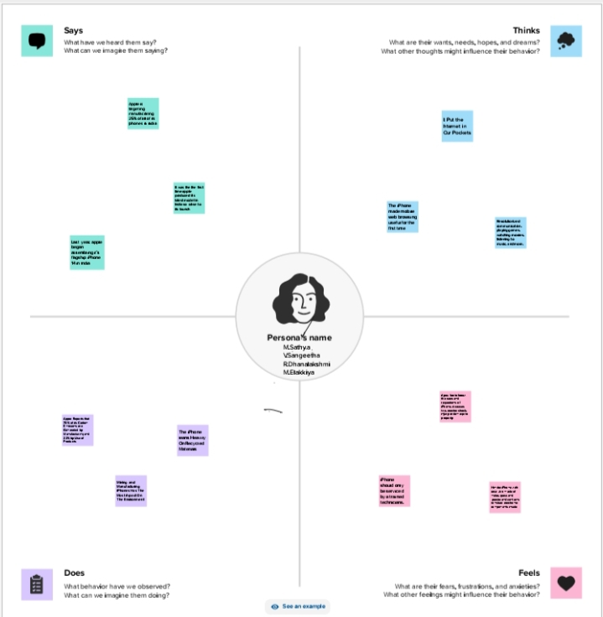

**2.2 Ideation and Brainstorming Map**

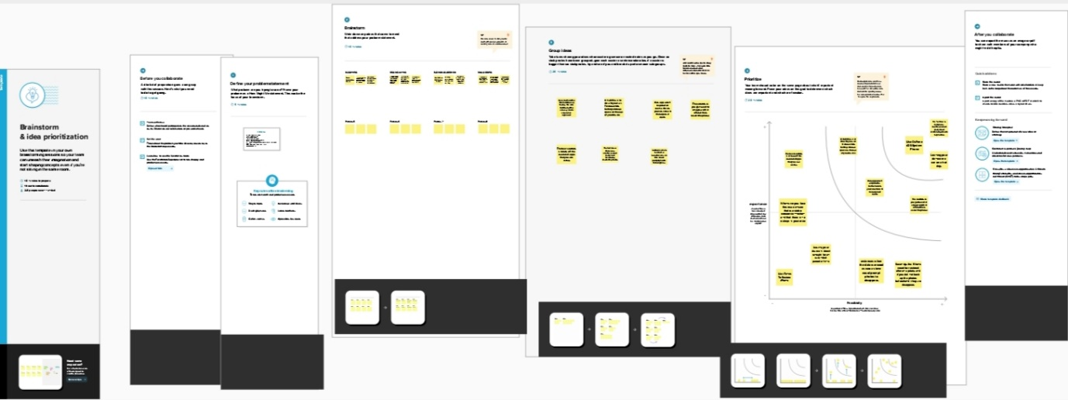

**3.RESULT**

**Market Penetration :** High adoption rates observed, especially in urban areas. Graphs depicting iPhone sales trends over the years.

**Economic Impact :** Contribution to the Indian economy in terms of jobs and revenue. Comparison charts showing Apple's economic impact in India.

**Consumer Behavior :** User preferences and buying patterns analyzed through surveys. Screenshots of survey questions and response summaries.

**Social Influence**: iPhone's role in shaping social trends and digital culture.

Social media engagement metrics and influential user testimonials.

**Challenges Faced:** Market challenges and competition faced by Apple in India. Infographics illustrating market challenges and strategic responses.

**Innovation and Technology Transfer:** Impact on local technology innovation and knowledge transfer. Screenshots of innovative apps and technologies developed in India due to iPhone.

**Future Outlook :** Predictions for iPhone's future growth and evolution in the Indian market.Visualizations showcasing future market projections and potential areas of expansion.

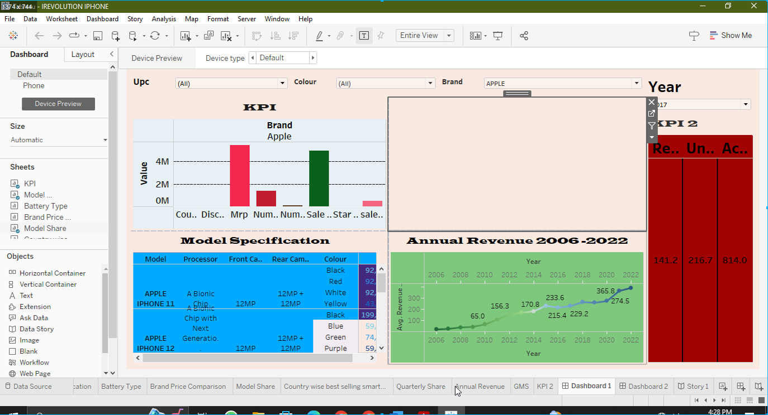

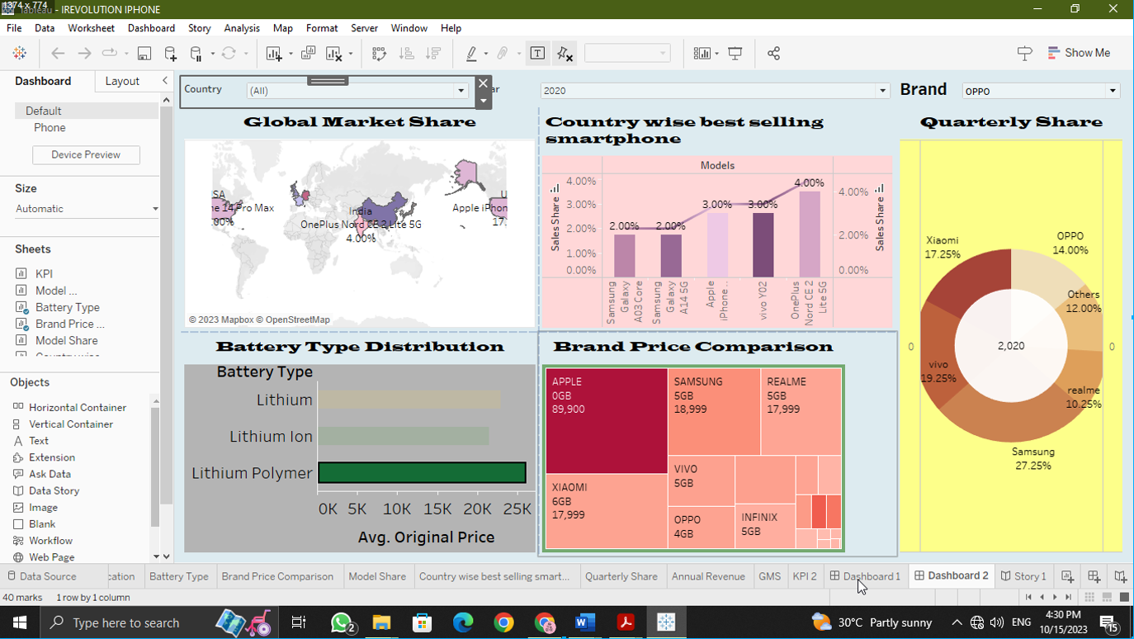

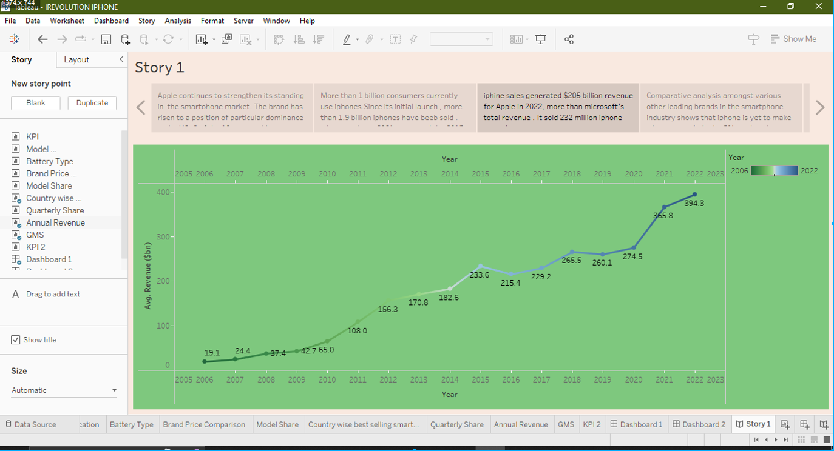

**4.ADVANTAGES AND DISADVANTAGES.**

**Advantages**

**Informed Decision Making**: Utilizing data helps in making decisions based on real facts and figures, aiding businesses, policymakers, and researchers in understanding the market better.

**Identifying Trends:** Data analysis can reveal market trends, consumer preferences, and purchasing patterns, enabling businesses to adapt their strategies accordingly.

**Targeted Marketing:** Analyzing data allows for targeted marketing efforts, ensuring that promotional activities are focused on the specific audience interested in Apple iPhones.

**Improving Products:** Feedback and usage data can aid Apple in refining their products to better suit the Indian market, leading to customer satisfaction and increased sales.

**Economic Impact Assessment:** Understanding the iPhone's impact on the Indian economy, job creation, and related sectors can provide valuable insights for policymakers.

**Disadvantages:**

**Data Privacy Concerns:** Analyzing user data raises concerns about privacy, necessitating stringent measures to safeguard individuals' sensitive information.

**Data Accuracy:** The accuracy of the data collected and analyzed is crucial. Inaccurate or biased data can lead to flawed conclusions and misguided decisions**.**

**Resource Intensive:** Data analysis requires significant resources in terms of skilled personnel, technology, and time, which might be a challenge for some organizations**.**

**Interpretation Challenges:** Interpreting data correctly is essential. Misinterpretation can lead to misguided strategies and actions, causing potential losses.

**Overreliance on Data:** Relying solely on data might ignore qualitative aspects such as cultural nuances and human experiences, providing an incomplete picture.

**5.APPLICATIONS:**

**Economic Impact:** Analyzing iPhone sales data to understand its contribution to the Indian economy .Studying the effects on local businesses and job creation in related industries.

**Consumer Behavior:** Examining consumer spending patterns and preferences related to iPhones.Assessing the shift in purchasing behavior after iPhone introduction.

**Technology Adoption:** Analyzing data on smartphone usage trends and how iPhones compare.Exploring the impact on digital literacy and technology adoption rates in urban and rural areas.

**Social Influence:** Studying iPhone's influence on social media usage and online interactions.Investigating the role of iPhones in shaping social status and aspirations among Indian consumers.

**Market Competition:** Analyzing market share data and the competitive landscape among smartphone brands.Understanding the strategies adopted by local competitors in response to iPhone's presence.

**Infrastructure Development:** Exploring the expansion of cellular networks and internet infrastructure due to increased smartphone usage.Studying the demand for supporting services like mobile apps and digital payment systems.

**Cultural Impact:** Researching how iPhones have influenced popular culture, including movies, music, and advertising.Examining the impact on language use, particularly in the context of smartphone interfaces.

**Environmental Sustainability:** Investigating iPhone's environmental footprint in terms of electronic waste and energy consumption.Analyzing Apple's initiatives in India related to recycling and sustainable manufacturing.

**Government Policies:** Studying government policies and regulations influenced by the proliferation of iPhones.Analyzing taxation and import/export policies concerning smartphones in India.

**6.CONCLUSION**

**Economic Growth:** iPhone's presence in India led to a significant boost in the economy, contributing to job creation and revenue generation.

**Digital Inclusion:** The iPhone played a pivotal role in bridging the digital divide, enabling millions to access online services, education, and employment opportunities.

**Technological Advancement**: Its impact on the tech sector spurred innovation, encouraging the development of local apps and services, thereby enhancing the overall digital infrastructure.

**Changing Consumer Behavior:** The iPhone influenced consumer preferences, shaping a new era of smartphone usage patterns and transforming the way people interact with technology.

**Market Dynamics:** The study revealed shifts in market dynamics, including increased competition, pricing strategies, and market share trends, driven by the iPhone's influence**.**

**Social Implications**: iPhones became status symbols, impacting social norms and lifestyles, creating a ripple effect on societal behaviors and aspirations.

**7.FUTURE SCOPE**

**Market Penetration Analysis :** Evaluate iPhone's market share in India over time.Analyze regional variations in iPhone adoption.

**Economic Impact:** Study the economic contribution of iPhone sales to India's GDP.Assess the impact on local businesses, like Apple resellers and app developers.

**User Behavior and Preferences:** Conduct surveys to understand user preferences and buying patterns.Analyze app usage data to identify popular applications among iPhone users in India.

**Socio-Cultural Influence:** Investigate how iPhones influence social status and lifestyle choices.Explore the integration of iPhones into cultural practices and traditions.

**Supply Chain and Job Creation:** Examine the local job creation due to iPhone manufacturing and supply chain operations.Evaluate the environmental and social sustainability of Apple's operations in India.

**Digital Divide and Inclusivity:** Study how iPhones contribute to reducing the digital divide in India.Explore initiatives aimed at making iPhones accessible to underprivileged communities.

**Policy Impact:** Analyze the impact of Indian policies and regulations on iPhone sales and manufacturing.Evaluate the effectiveness of government incentives in promoting iPhone production in India.

**Technological Ecosystem:** Investigate the growth of Apple's app ecosystem in the Indian market.Examine collaborations between Apple and Indian tech companies for app development and innovation.

**Customer Support and Service:** Evaluate customer satisfaction levels regarding iPhone service and support in India.Analyze the effectiveness of Apple's service centers and online support in the country.

**Future Trends and Predictions:** Predict future trends in iPhone adoption based on current data and market indicators. Anticipate the potential challenges and opportunities for Apple in the Indian market.